

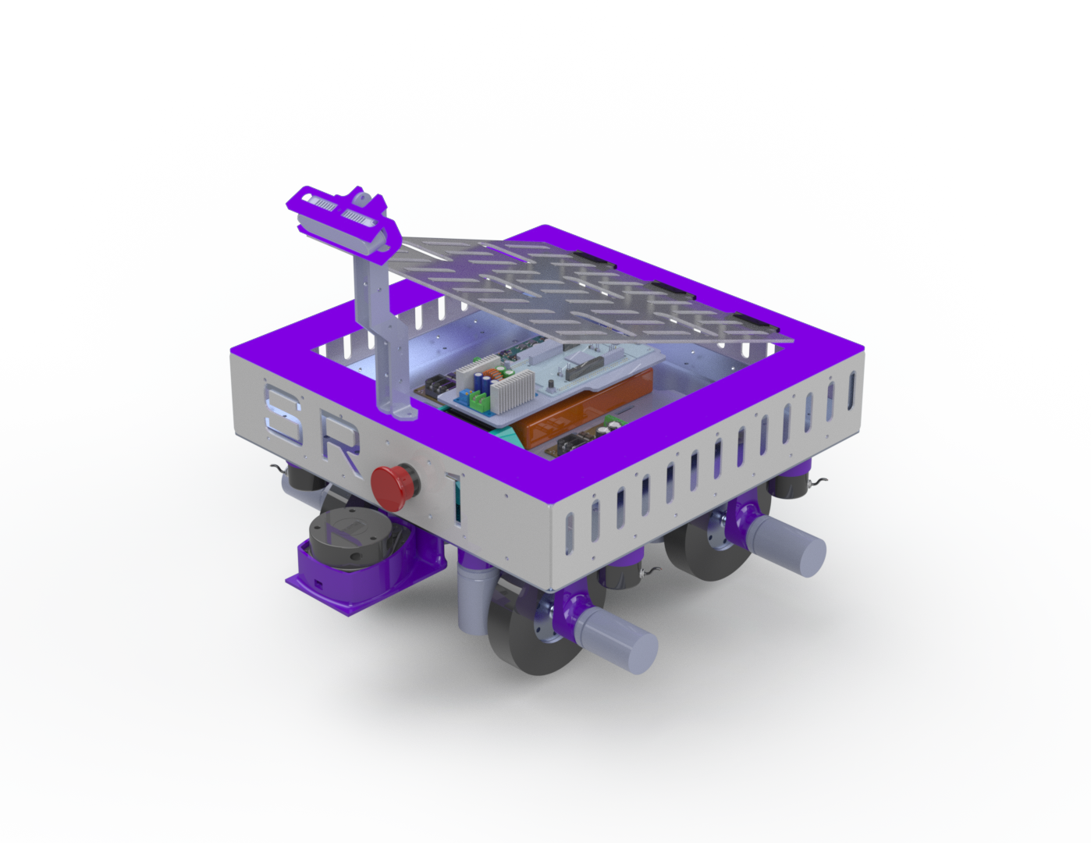

**Intelligent Ground Vehicle Competition**

Ideation Stage / Concept, Robofest 5.0

Prepared By – ***Team SR-01***

**Team Details**

**College Name:** G H Patel College of Engineering and Technology

**Address:** Bakrol Road, Mota Bazaar, Vallabh-Vidhyanagar, Anand-388120



**Mentor**: Dr. Vinod Patel

**Mentor Email:**  vinodpatel@gcet.ac.in

**Mentor Mobile No:** +91 9537869801

**•** M.E. in Mechanical Engineering (**Specialization:** **Machine Design**) – BVM Engineering College

• Ph.D. in Mechanical Engineering – **IIT Delhi**, New Delhi

• **Mentor** for the college **ROBOCON team in 2024 and 2025**, actively guiding students in robotic design, control systems, and automation for national and international competitions.

• Received **₹50,000** from DST, GUJCOST for organizing the **3rd International Conference on Innovations in Automation and Mechatronics Engineering**

• Received **₹20,000** from DST, GUJCOST for conducting a **One-Week STTP** on *“Dynamic Analysis of Mechanism and Machine”*.

• Received **₹1,00,000** from DST, GUJCOST for organizing the **International Conference on Innovations in Automation and Mechatronics Engineering (ICIAME 2013)**

**Student Details**

|  |  |  |  |  |
| --- | --- | --- | --- | --- |
| **Sr. No** | **Name** | **Photos** | **Role** | **Email ID** |
| **1.** | **Harshil Joshi** |  | **Mechanical Design** | **heyharshil@gmail.com** |
| **2.** | **Jash Borad** |  | **ROS2 Development & Deployment** | **jashborad13@gmail.com** |
| **3.** | **Kush Patel** |  | **Electronics**  **and Embedded**  **System** | **kushcpatel017@gmail.com** |
| **4.** | **Pushti**  **Nagrecha** |  | **Computer**  **Vision** | **nagrechapushti16@gmail.com** |

**Table of Content**

**List of Figures .................................................................................................................................. v**

**List of Tables .................................................................................................................................. vi**

**1. Type of Robot ............................................................................................................................. 1**

* **1.1 Overview of the Proposed Robot**
* **1.2 Key Capabilities of Robot**
* **1.3 Drive Mechanism: 4-Wheel Independent Swerve Drive**

**2. Robot Assembly Design (Proposed Diagram) ................................................................. 3**

* **2.1 Mechanical CAD Overview**
* **2.2 Chassis Design**
* **2.3 Component Integration Layout**

**3. Components to be Used ........................................................................................................ 10**

* **3.1 Structure Components**
* **3.2 Motion Components**
* **3.3 Electronics Components**

**4. Methodology of Robot Development ............................................................................... 24**

* **4.1 Mechanical Fabrication Steps**
* **4.2 Electronics Integration Process**
* **4.3 Software Integration (ROS 2)**

**5. Applications of the Proposed Robot in a societal context......................................... 30**

**6. Size of Robot – Proof of Concept (Small Version) ........................................................ 31**

* **7.1 Dimensions**

**7. Size of Robot – Prototype (Full-Scale Version) ............................................................. 31**

* **8.1 Final Dimensions**

**8. Timeline for Robot Development with Milestones ..................................................... 32**

* **9.1 Activity vs. Duration (Gantt Chart)**

**9. Proposed Outline (Visual Representation) ................................................................... 33**

**10** **Undertaking For the Patent............................................................................................... 35**

**List of Figures**

***Figure 1. 2D Multi-View Layout of SR-01* ............................................................................ 3**

***Figure 2. 3D Isometric View of Full Robot* .......................................................................... 4**

***Figure 3. 3D Front View of SR-01* .......................................................................................... 4**

***Figure 4. 3D Back View of SR-01* ........................................................................................... 5**

***Figure 5. 3D Top View of SR-01* ............................................................................................. 5**

***Figure 6. 3D Bottom View of SR-01* ...................................................................................... 6**

***Figure 7. 3D Side View of SR-01* ............................................................................................ 6**

***Figure 8. Swerve Drive Module* ............................................................................................. 7**

***Figure 9. Swerve Drive Kinematic Representation* ………………………………………....... 8**

***Figure 10. Load Analysis* ....................................................................................................... 24**

***Figure 11. System Block Diagram* ...................................................................................... 25**

***Figure 12. Gazebo and RViz Simulation in ROS* .............................................................. 27**

***Figure 13. Layered Architecture for Perception, Planning, and Control* ………...... 29**

***Figure 14. Gantt Chart* ……………………………………………………………………….………...... 32**

***Figure 15. Rendered Image of SR-01 in Real Environment*……………….….……..….... 33**

**List of Tables**

***Table 1. List of Structure Components* ............................................................................... 13**

***Table 2. List of Motion Components* .................................................................................... 14**

***Table 3. List of Electronic Components* .............................................................................. 15**

***Table 4. POC Dimension* .......................................................................................................... 31**

***Table 5. Prototype Dimension* ............................................................................................... 31**

***Table 6. Timeline* ....................................................................................................................... 32**

# **TYPE OF ROBOT**

## **Intelligent Ground Vehicle**

**1.1 Overview of the Proposed Robot**

The aim is to develop an Intelligent Ground Vehicle (IGV), an autonomous vehicle made for ground navigation in both even and uneven terrains. Its design focuses on environment perception, route planning, and adaptive control to provide stable and safe navigation.

Unlike remote-operated or fixed-program robots, the IGV is able to detect its environment, interpret sensor inputs, and take autonomous decisions for navigation. With these abilities, it can avoid obstacles, adjust to different surfaces, and move smoothly without human help.

Our prototype, called ***SR 01***, is equipped with navigation modules, terrain-handling features, and a four-wheel swerve drive to deliver agile and reliable mobility in complex environments.

**1.2 Key Capabilities**

**Key Capabilities**

* **Self-driving ability:** The vehicle can move by itself on both straight tracks and complex routes without manual control.
* **Obstacle detection:** With the help of LiDAR, cameras, it can identify objects ahead and find a safe way around them.
* **Terrain stability:** The system can stay balanced and continue moving even on uneven ground, ramps, or narrow paths.
* **Route decisions:** The vehicle can read codes or signs (like QR/AR markers) and use them to choose the right way forward.

**1.3 Drive Mechanism: 4-Wheel Swerve Drive System**

The SR01 has a **4-wheel independent swerve drive system**, which provides omnidirectional movement control compared to traditional drive mechanisms such as differential. Each wheel is individually powered and steered, offering omnidirectional movement.

**Features of the Swerve Drive**

* **360 Degree Wheel Rotation:** Allows un-constrained motion in any direction
* **Sideways Movement:** The robot can move in any direction without any kind of rotation.
* **Controlled Mobility:** It can fit into narrow spaces and turn sharply without difficulty.
* **Terrain Handling:** The wheels stay stable on bumpy surfaces, ramps up to 45°, and narrow bridges.
* **Precise Control:** Each wheel is managed independently, which keeps the robot aligned and prevents slipping.

This system makes SR01 particularly effective in **IGVC tasks**, including sharp turns, obstacle avoidance, and narrow passage navigation.

* 1. **ROBOT ASSEMBLY DESIGN**

**2.1 Mechanical CAD Overview**

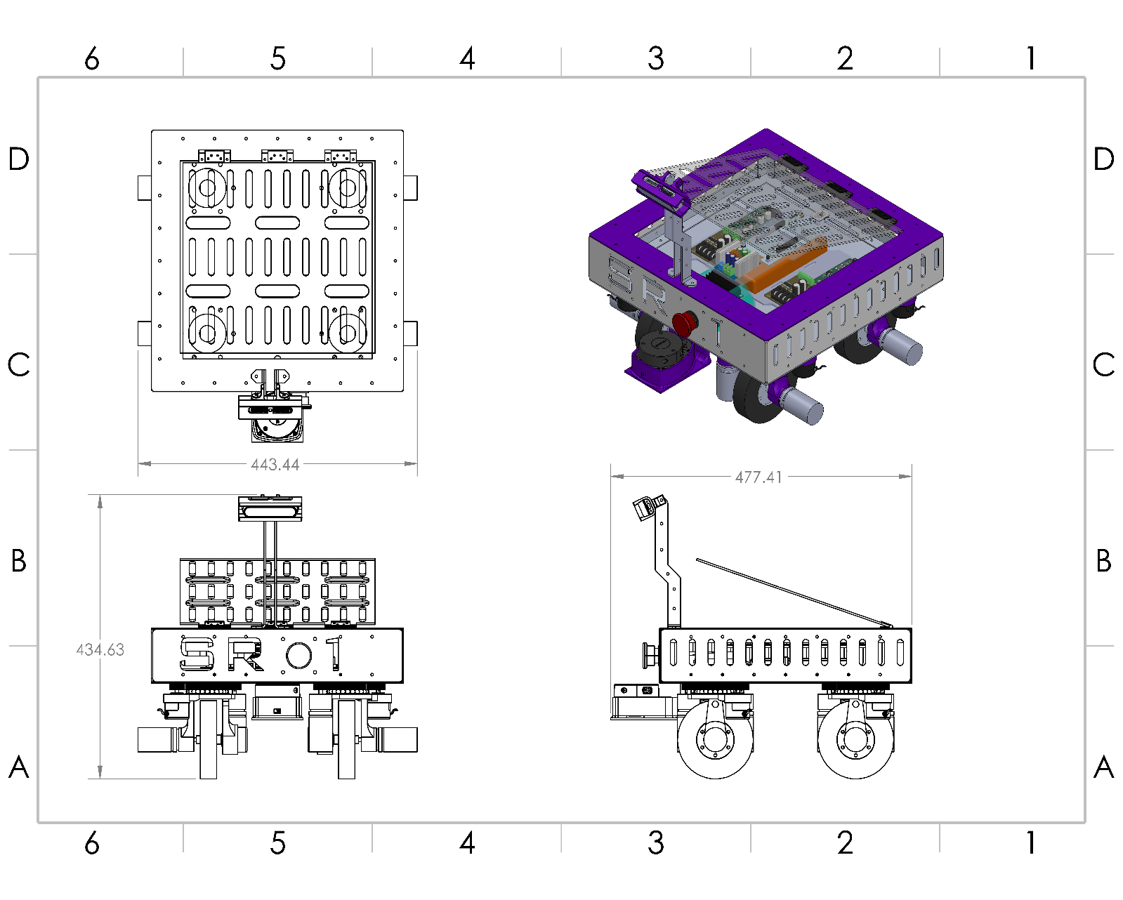

***Figure 1. 2D Multi View Layout of SR-01***

**2.2 Chassis Design**



***Figure 2. 3D Isometric View of full Bot***

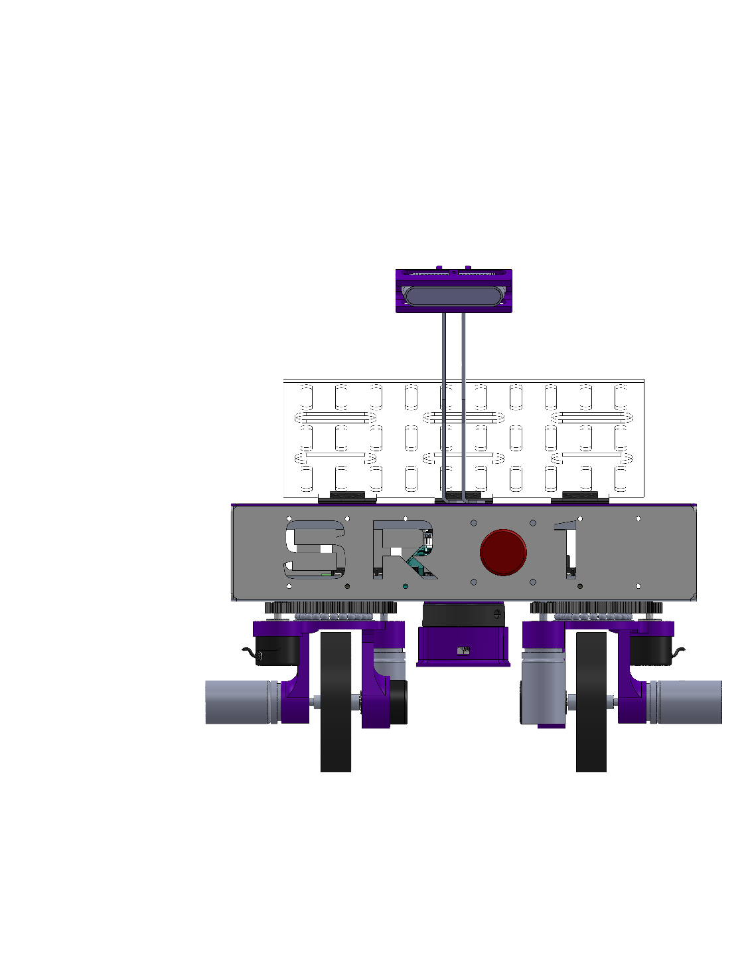

***Figure 3. 3D Front View of SR-01***

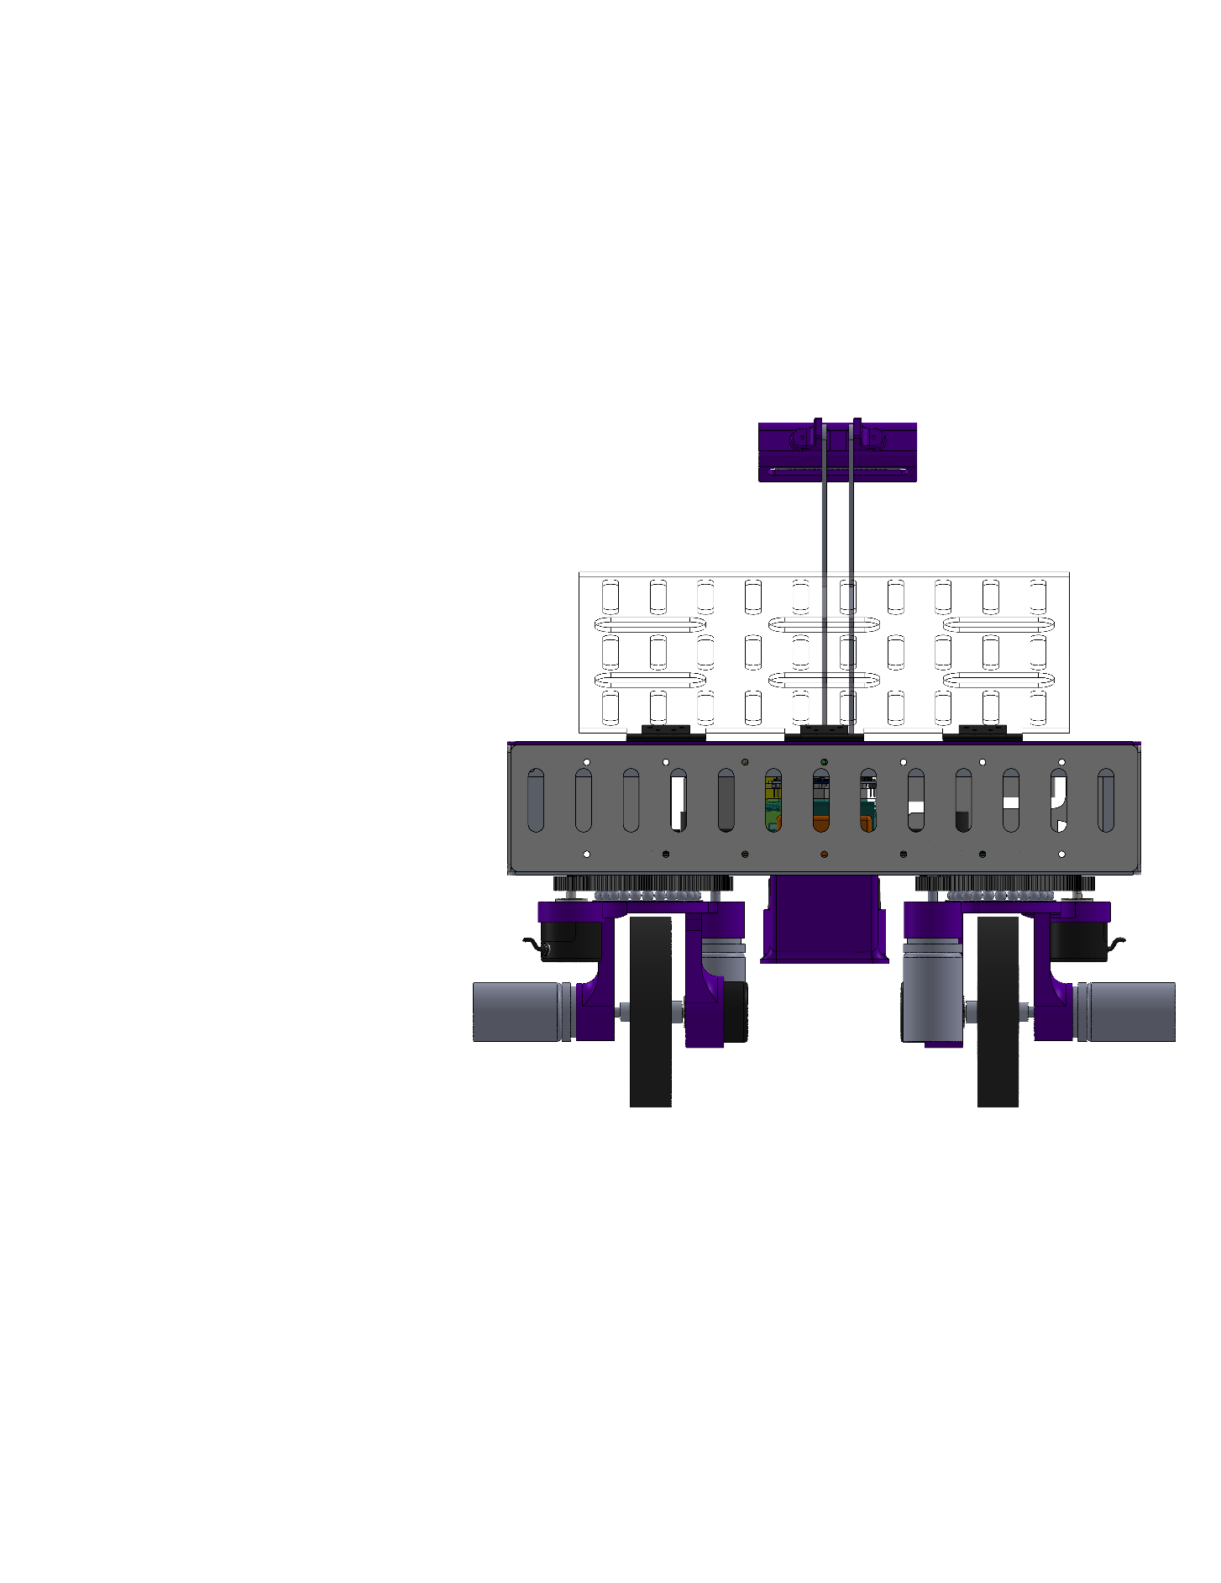

***Figure 4. 3D Back View of SR-01***

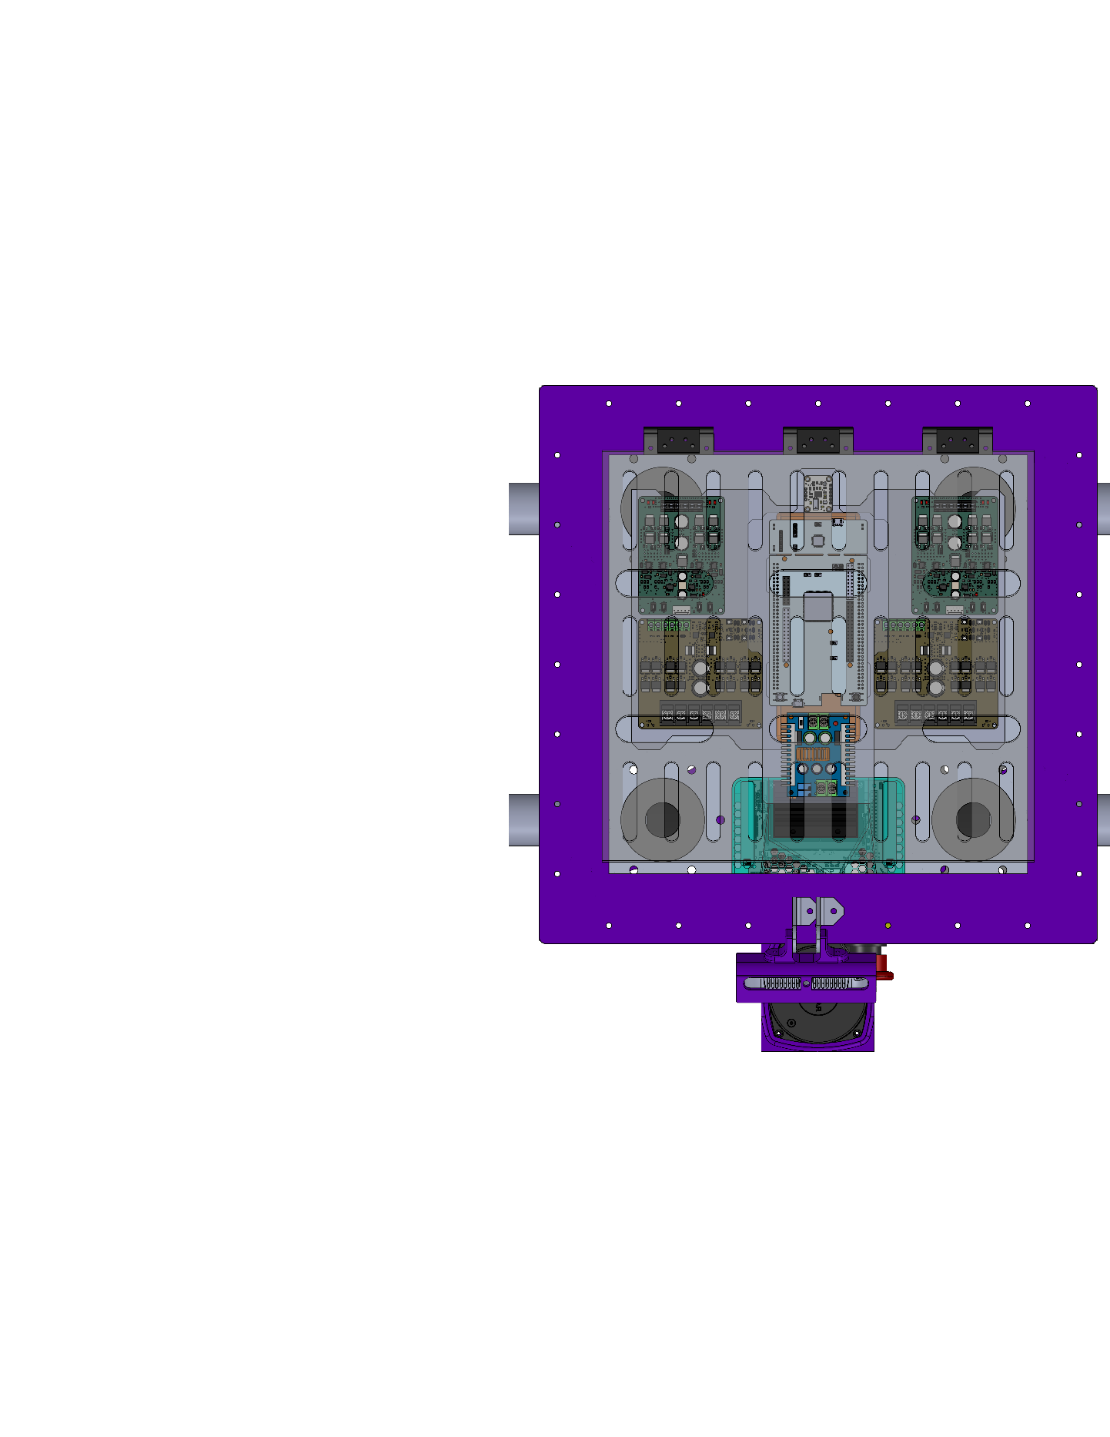

***Figure 5. 3D Top View of SR-01***

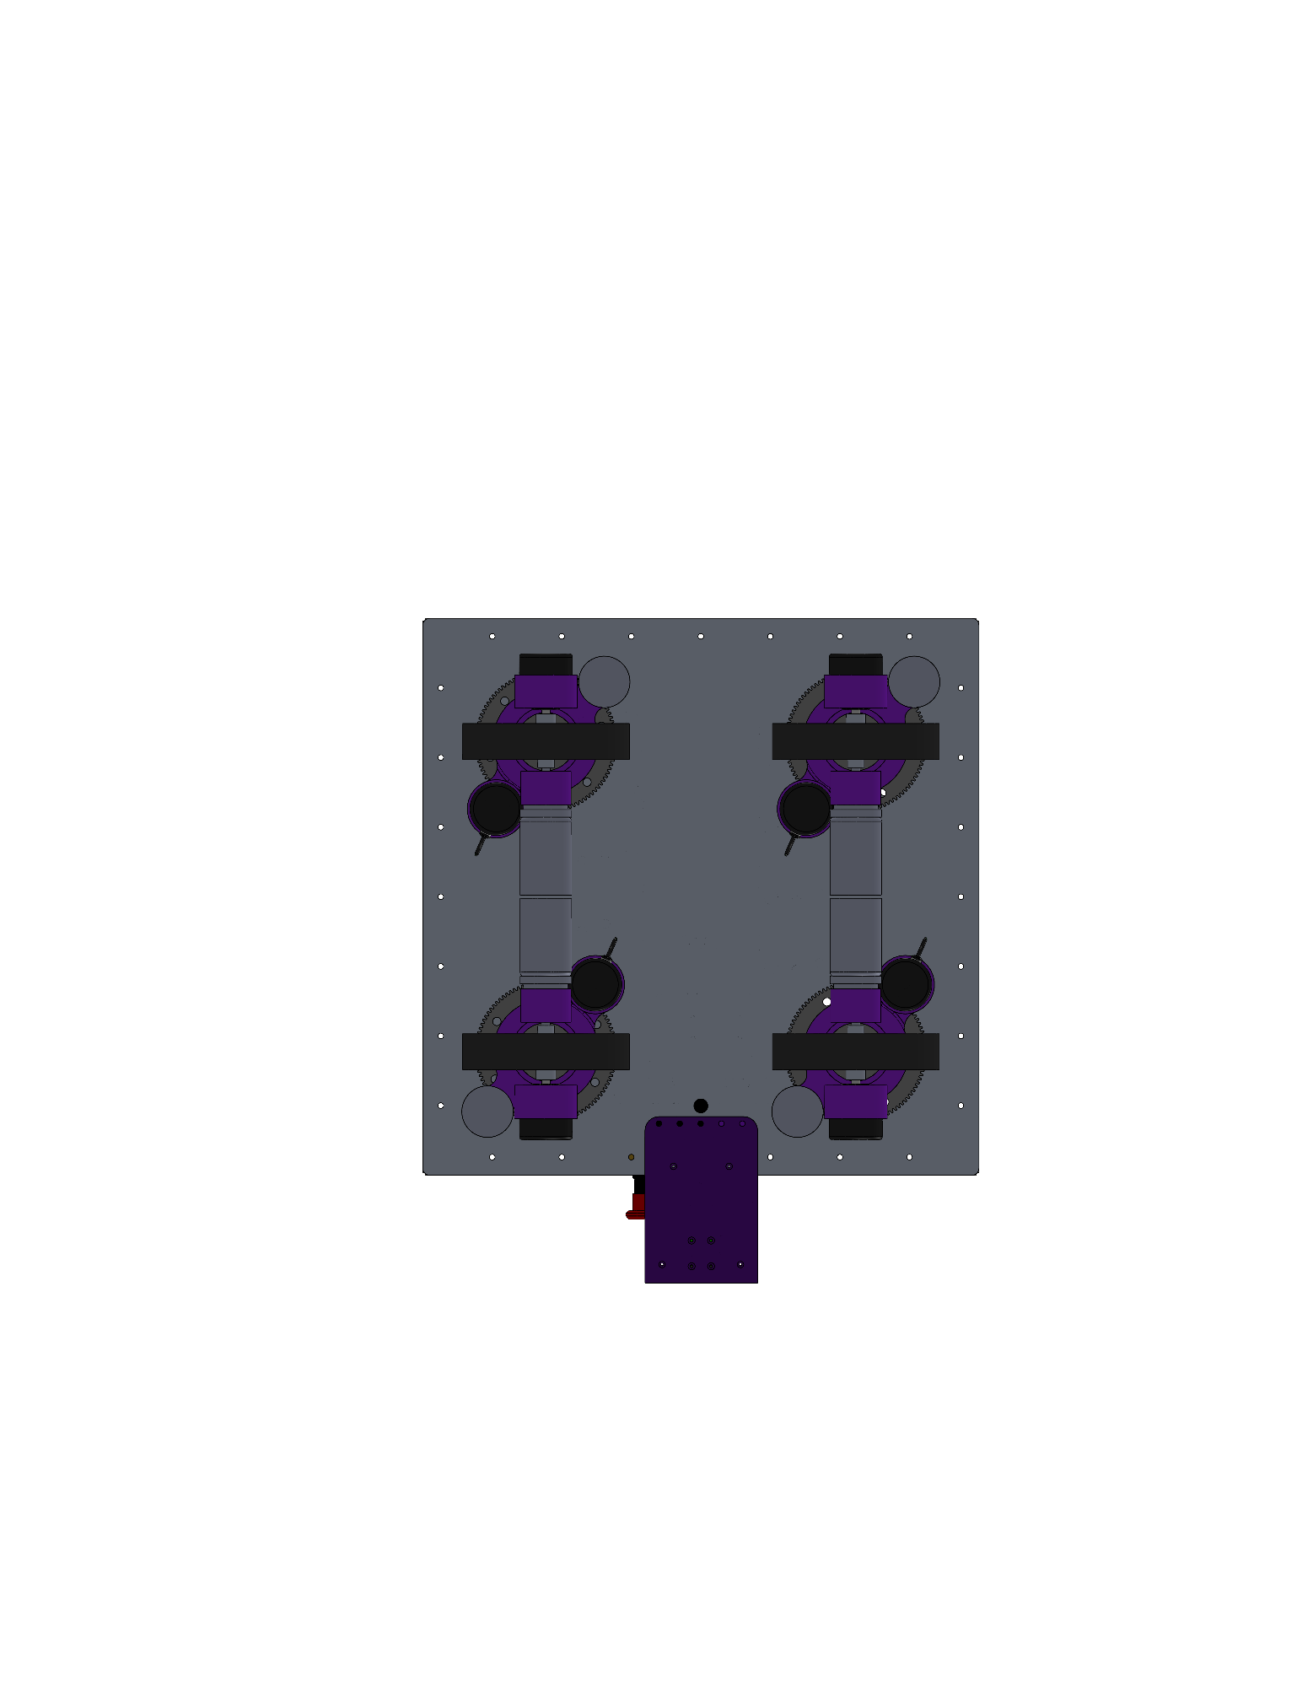

***Figure 6. 3D Bottom View of SR-01***

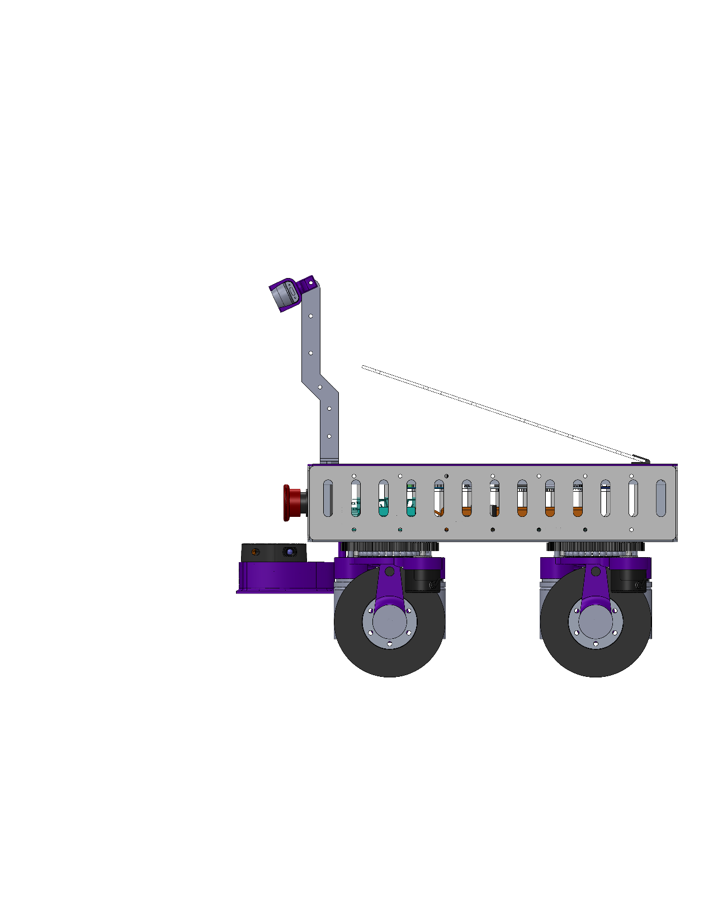

***Figure 7. 3D Side View of SR-01***

**2.3 Component Integration Layout**

|  |  |
| --- | --- |
| ***Sr.no*** | ***Part Names*** |
| ***1.*** | *Steering Gear* |
| ***2.*** | *Steering Motor* |
| ***3.*** | *Drive Encoder* |
| ***4.*** | *Encoder Coupling* |
| ***5.*** | *PU- Wheel* |
| ***6.*** | *Drive Coupling* |
| ***7.*** | *Drive Motor* |
| ***8.*** | *Steer Encoder* |
| ***9.*** | *Encoder Gear* |
| ***10.*** | *Thrust Bearing* |
| ***11.*** | *Stationary Gear* |
| ***12.*** | *Housing* |

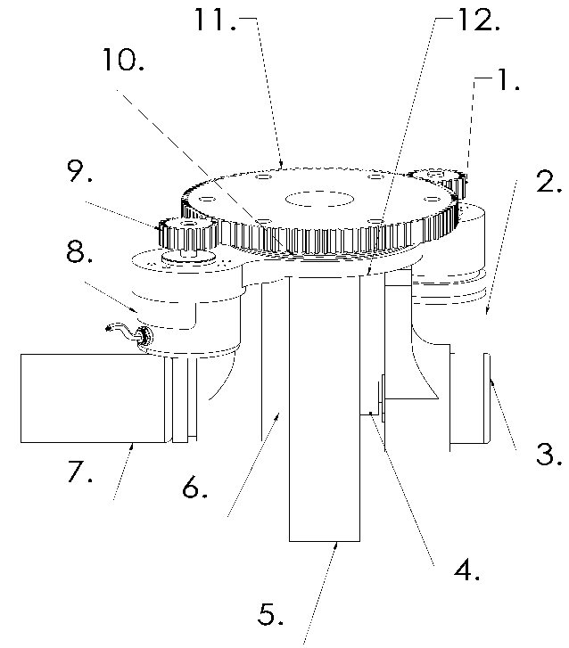

***Figure 8. Swerve Drive Module***

The swerve mechanism is composed of a driving motor, steer motor, fixed gear and steer gear, steer encoder, driving encoder, motor enclosure, thrust bearing, PU wheel, driving coupler, and encoder coupler.

The stationary gear is affixed to the chassis and the thrust bearing is locked between the stationary gear and the motor housing. This allows for the load to transfer through the chassis to the wheel, and allowing smooth steering.

The steer motor and encoder, steer gear, and encoder gear are all mounted vertically, and they all mesh with stationary gear. The steer motor produces the torque required by providing a gear reduction of **1:5.57** to provide a smooth rotation of the swerve module. Finally, the steer encoder produces feedback to compensate for errors, confirm motion and measure motion in relation to desired motion.

The PU wheel has a high-RPM motor directly mounted to it for efficient torque transfer and to have a smaller profile. PU wheels were selected because they can carry a heavy payload, have a strong grip, and resist wear and tear. An encoder is mounted on the same shaft to accurately calculate the linear motion.

**Kinematic Modelling of 4-Wheel Swerve Drive**

**System Configuration**

* **Chassis:** Square frame with half-length L and half-width W
* **Wheels:** 4 independent modules, each with steering motor (θᵢ) and drive motor (vᵢ)
* **Steering Range**: ±90° per wheel $\left[-\frac{π}{2},\frac{π}{2}\right]$
* **Coordinate System:** Origin at chassis center, X-forward, Y-left

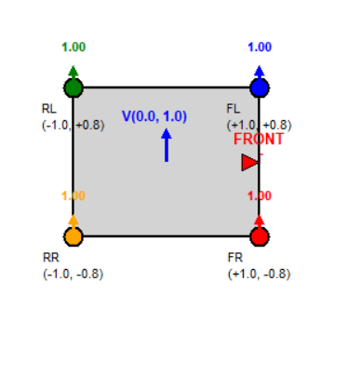**Wheel Positions**

***Figure 9. Swerve Drive Kinematic Representation***

**Wheel 1 (FR):** *( L, -W*) **Wheel 2 (FL)**: *( L, W)*

**Wheel 3 (RL):** *(-L, W)* **Wheel 4 (RR)**: *(-L, -W)*

**Input:** Desired chassis velocity $\left[V_{x},V_{y},ω\right]$  
**Output:** Wheel commands [θ₁, θ₂, θ₃, θ₄, v₁, v₂, v₃, v₄]

**Algorithm Steps**

**1. Calculate wheel velocity components:**

$v_{1x}=V_{x}+ω×W$ $v_{1y}=V_{y}+ω×L$ (FR)

$v_{2x}=V_{x}-ω×W$ $v_{2y}=V_{y}+ω×L$ (FL)

$v_{3x}=V_{x}-ω×W$ $v_{3y}=V_{y}-ω×L$ (RL)

$v_{4x}=V_{x}+ω×W{ v}_{4y}=V_{y}-ω×L$ (RR)

**2. Calculate raw steering angles:**

$θ_{i,\text{raw}}=\text{atan2 }\left(v_{iy},v_{ix}\right)$ for i = 1,2,3,4

**3. Normalize to steering range:**

Since physical steering mechanisms are typically limited to ±90°, we normalize the angles:

* If $\left|θ_{i,\text{raw}}\right|≤\frac{π}{2}$ **:**
 $θ_{i}=θ_{i,\text{raw}}$

 + Sign multiplier sᵢ = **+1 (Forward Direction)**
* If $θ_{i,\text{raw}}>\frac{π}{2}$:
  + $θ_{i}=θ_{i,\text{raw}}-$ 𝝅
  + Sign multiplier sᵢ = **-1 (Negative Direction)**
* If $θ_{i,\text{raw}}<-\frac{π}{2}$:
  + $θ_{i}=θ_{i,\text{raw}}+$ 𝝅
  + Sign multiplier sᵢ = **-1 (Negative Direction)**

This normalization ensures the steering angle remains within mechanical constraints while maintaining the correct direction of motion through the sign multiplier.

**4. Calculate drive speeds:**

* 1. **COMPONENTS TO BE USED:**

**3.1 Structure Components**

|  |  |  |  |
| --- | --- | --- | --- |
| **Sr. No.** | **Component Name** | **Figure** | **Description** |
| **1.** | **Top Plate** |  | Plate with accessible lead for easy access to electronics modification. |
| **2.** | **Bottom Plate** |  | It is use to mount stationary Gear to transmit load Equally to all four module. |
| **3.** | **Front Plate** |  | Plate with team name and manual kill switch. |
| **4.** | **Side Plate** |  | Plate use to form encloser of chassis. |
| **5.** | **L-section** |  | It is use to make a rigid frame for chassis. |
| **6.** | **Thrust Bearing** |  | It is use to transfer load between chassis and swerve module also Provide smooth motion. |
| **7.** | **Motor**  **Encloser** |  | Singular piece which can house encoder, motor and thrust bearing. |
| **8.** | **Camera**  **Mounting** |  | Camera mounting at front center, aligned horizontally, with adjustable tilt for optimal field of view |
| **9.** | **Camera Mounting Extender** |  | Angled camera mounting extender with bolt holes for forward positioning. |
| **10.** | **Pu -wheel** |  | Heavy duty wheel for rough terrain and with stand heavy load and provide good grip. |
| **11.** | **Rhino Planetary -300RPM -20 Kg.cm (Driving motor)** |  | It is use for driving the wheel and give bot linear motion. |
| **12.** | **Acrylic Lid** |  | Mounted on the top plate to allow a clear view of the chassis interior. |
| **13.** | **Hinge** |  | It is used to enable the opening and closing of the acrylic lid. |
| **14.** | **11.1V 10000mAh 35C 3S Lithium- Ion Battery Pack** |  | A rechargeable Li- Ion battery that provides 11.1V output with high capacity for long-lasting power. |

***TABLE 1. LIST OF STRUCTURE COMPONENTS***

**3.2 Motion Components**

|  |  |  |  |
| --- | --- | --- | --- |
| **Sr. No.** | **Components** | **Figure** | **Description** |
| **1.** | **Motor Coupling** |  | It is use to connect motor and wheel. |
| **2.** | **Encoder Coupling** |  | It is use to Give output from wheel to encoder. |
| **3.** | **Stationary Gear** |  | Acts as a fixed part of the steering system, to transmit motion to steering mechanism. |
| **4.** | **Steer Gear** |  | It is use to steer swerve module. |
| **5.** | **Encoder Gear** |  | It is use to take feedback from Steering. |

***TABLE 2. LIST OF MOTION COMPONENTS***

**3.3 Electronics Components**

|  |  |
| --- | --- |
| **Sr. No.** | **Components** |
| ***Processing & Control Units*** | |
| 1. | Nvidia Jetson Nano Development Kit |
| 2. | STM32F446ZE Development Board |
| ***Motor Control & Actuation*** | |
| 3. | Cytron MDD20A Dual Channel 20Amp DC Motor Driver |
| 4. | Cytron MDD10A Dual Channel 10Amp DC Motor Driver |
| 5. | Pro-Range 600 PPR 2-Phase Incremental Optical Rotary Encoder |
| ***Sensors & Perception Units*** | |
| 6. | BNO086 9-DOF VR IMU |
| 7. | SLAMTEC RPLiDAR A1M8 360 Degree Laser Range Finder – 6m |
| 8. | Intel RealSense Depth Camera D435 |
| ***Power Supply Modules*** | |
| 9. | 300W 20A Step Down DC-DC Buck Converter |
| 10. | DC-DC 3A 5V-12V to, 5V Step-down Power, Supply Module |
| 11. | Emergency Stop Switch Push Button NC Element with box |

***TABLE 3. LIST OF ELECTRONIC COMPONENTS***

* 1. **Nvidia Jetson Nano Development Kit**

The Jetson Nano provides real-time processing for vision, sensor fusion, and navigation, ensuring smooth obstacle detection, path planning, and motor control with low power usage.

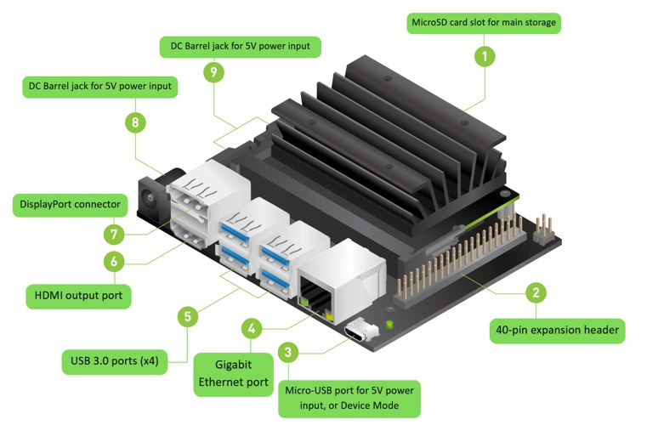

**FEATURES:**

* + - Quad-core ARM Cortex-A57 processor (1.43 GHz).
    - 128-core NVIDIA Maxwell GPU.
    - 4 GB LPDDR4 RAM.
    - MicroSD card storage interface.
  1. **STM32 – NUCLEO 144 F446ZE Development Board**

The STM32 Nucleo-144 (F446ZE) is the main microcontroller. It manages motor control and sensor interfacing using high-speed Cortex-M4 processing. With RTOS support, it provides efficient real-time task scheduling and stable robot performance.

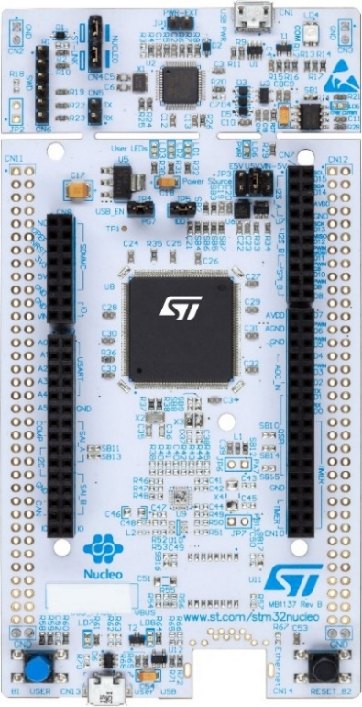

**FEATURES:**

* Fast Processing 180 MHz Cortex M4 with FPU.
* 128 KB of RAM and 512 KB of flash memory.
* USB OTG, CAN, SPI, I2C, and UART.
* Motor control with PWM and Hardware timers.
  1. **Cytron MDD20A Dual Channel 20Amp DC Motor Driver**

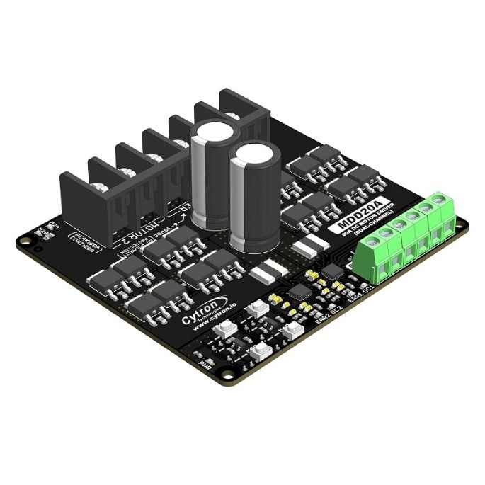This Dual Channel 20A Motor Driver supports the robot's drive motors. The Cytron MDD20A Dual Channel 20A Motor Driver maintains control over each channel with high current in both directions, and safety control features provide reliable and smooth operation.

**FEATURES:**

* Dual-channel motor driver supporting up to 20A per channel.
* Achieving accurate movement both forward and backward through bidirectional control.
* Proofed reliable operation with built-in safeguards for overcurrent, overheating, and undervoltage.
  1. **Cytron MDD10A Dual Channel 10Amp Motor Driver**

The Cytron MDD10A Dual Channel 10A Motor Driver controls the steering motors in your robot. It provides efficient bidirectional control. It also has enough current handling and protection features for stable operation.

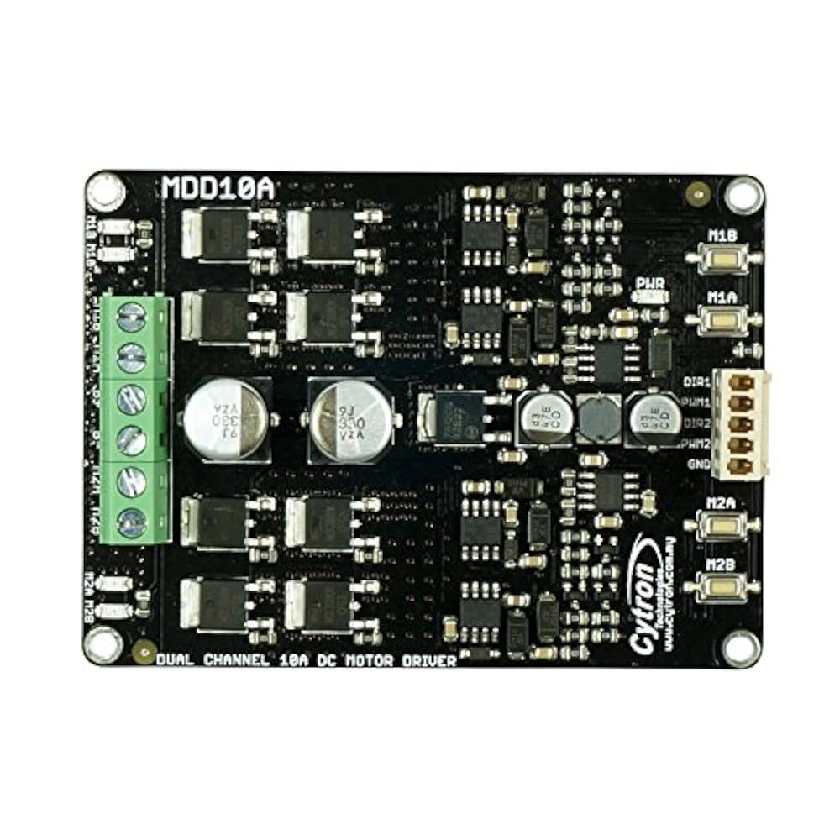

**FEATURES:**

* A dual channel driver supports a channel current of up to 10A.
* It offers precise control for steering motors with bidirectional capabilities.
* Integrated safeguards ensure excellent safety and stability.
  1. **Pro Range 600 PPR 2-Phase Incremental Optical Rotary Encoder**

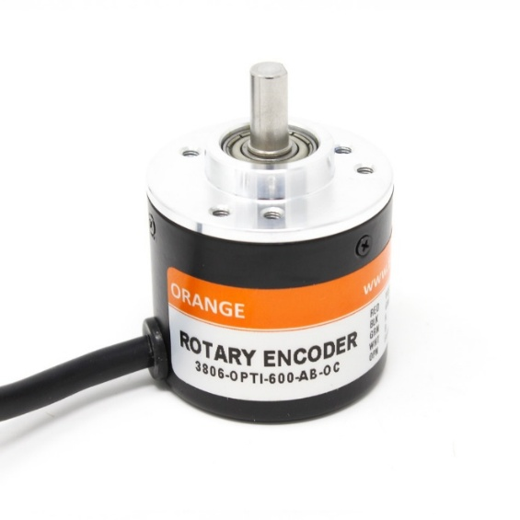The Pro Range 600 PPR optical encoder assists the robot in monitoring both the rotation and the direction of each wheel. It offers 2400 counts per revolution for precision motion feedback.

**FEATURES:**

* 600 PPR along with direction sensing for precise position feedback.
* 2400 counts per revolution for precise motion feedback.
* Built-in shielding on the 1.5m cable reduces noise.
* Pull-up resistors will give clean output signals.
  1. **BNO086 9-DOF VR IMU**

The BNO086 9-DOF IMU provides the robot with accurate orientation by combining accelerometer, gyroscope, and magnetometer data, ensuring stable navigation with <2° error.

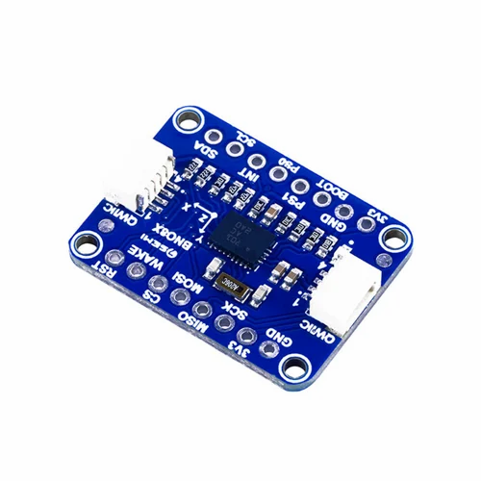

**FEATURES:**

* Integrated accelerometer, gyroscope, and magnetometer.
* Can be connected easily via I2C, SPI, and UART.
* Low power consumption (2.4V–3.6V) and efficient operation.
* Precise orientation output with less than 2° error.
  1. **Rotary LIDAR Sensor:**

RPLiDAR A1M8 360 Degree Laser Range Finder is a 360-degree 2D laser scanner that can perform a 360-degree scan within a 6-meter range. It produce 2D point cloud data can be used in mapping, localization, and object/environment modelling.

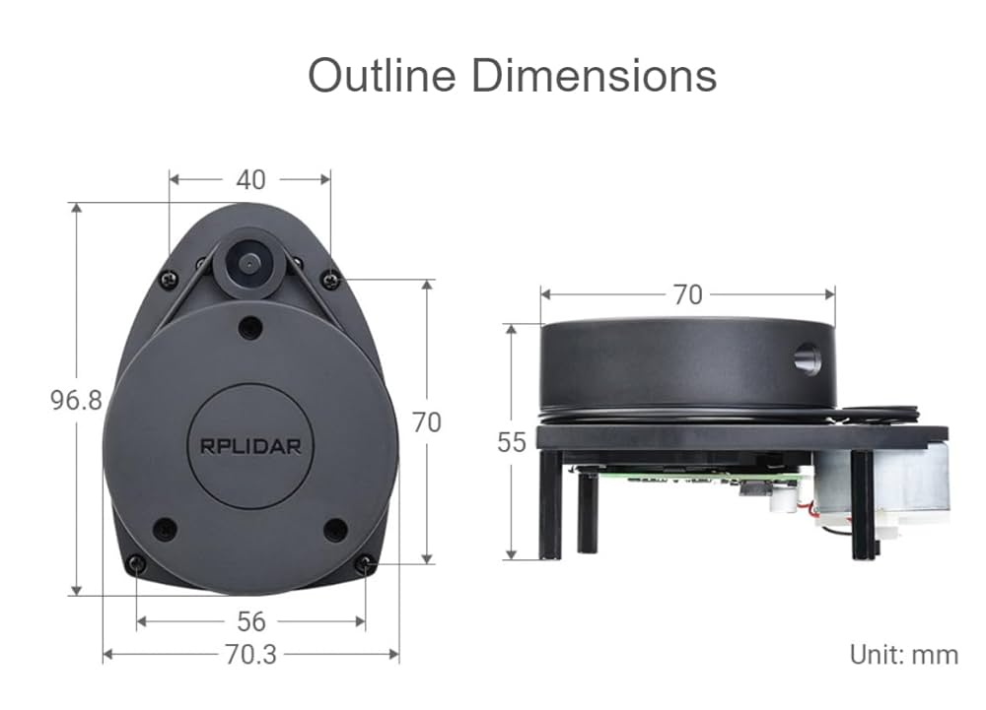

**FEATURES:**

* 360 Degree Omni directional Laser Range Scanning.
* 8000 times sample rate, the highest in the current economical LIDAR industry.
* Configurable Scan Rate of 2-10Hz.
* Ideal for Robot Navigation and Localization.
* 6-meter radius range.
  1. **Intel RealSense Depth Camera D435**

The Intel RealSense D435 provides 3d vision to the SR-01 robot for navigation and obstacle avoidance, that can be used for up to 10 m and is resistant to light and rapid movement.

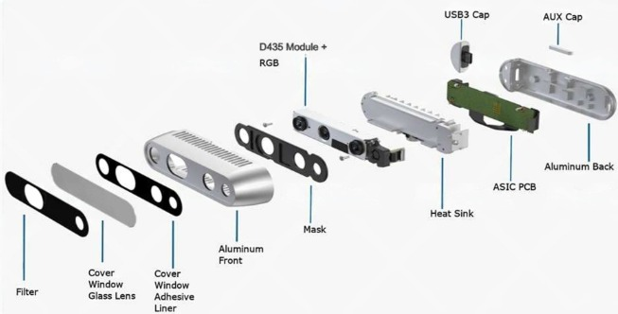

**FEATURES:**

* Provides high-resolution depth sensing up to 1280 × 720 at 90 fps.
* Fully supported by the Intel RealSense SDK 2.0 for for development across different platforms.
* It Has an integrated RGB camera and active IR projector for better 3D perception.
  1. **300W 20A Step Down DC-DC Buck Converter**

The 300W 20A DC-DC Buck Converter Step Down Module Constant Current LED Driver Module can be used to get adjustable output voltage ranges from 12V to 36V. With the heat sink mounted, it can easily manage to run high-power applications continuously.

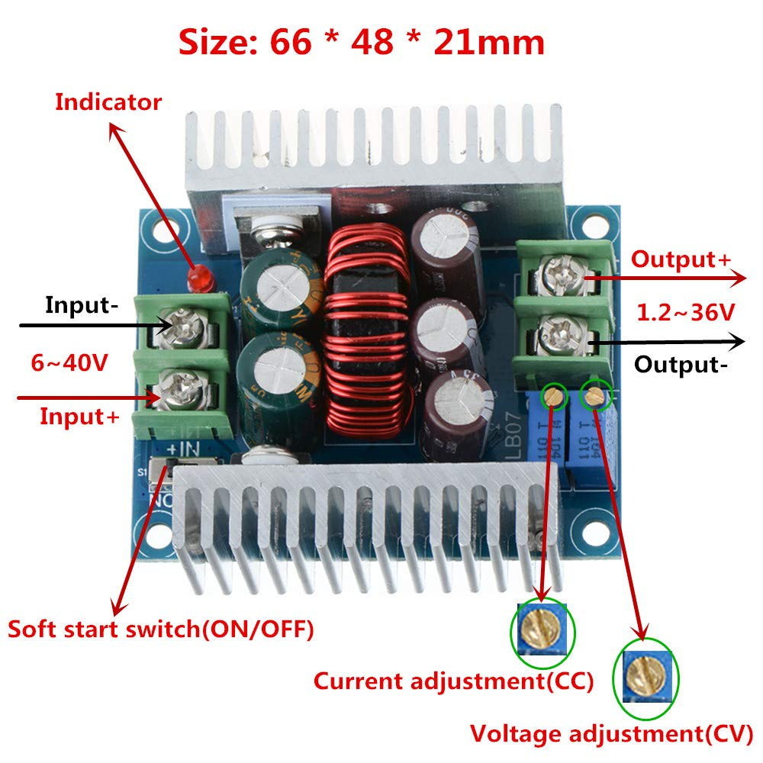

**FEATURES:**

* Constant Output current value of 15A.
* Output Ripple: about the ripple 50mV (without noise).
* Operating temperature: -10 °C to + 75 °C.
  1. **DC-DC 3A 5V-12V to, 5V Step-down Power, Supply Module**

This mini DC-DC step-down module can be used for stable 5V output from an input of 5-12V. It is reliable, and has over-load protection, over-heat protection, over-current protection, and short-circuit protection.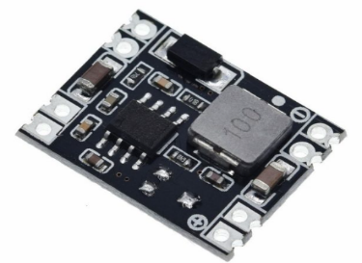

**FEATURES:**

* High conversion efficiency up to 97.5% for better power use.
* Reverse input polarity protection stops damage from incorrect power connections.
* Overvoltage and short-circuit protection on the output.
  1. **Emergency Stop Switch:**

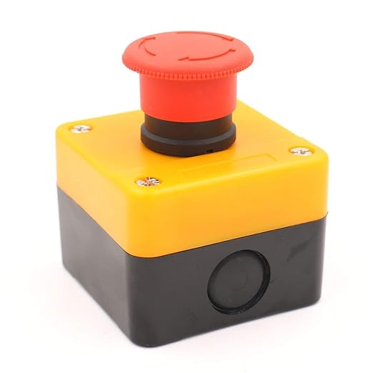Emergency Stop Switch is device which is use to stop a machine, a line, an assembly system, or a process completely.

**FEATURES:**

* Actuator Type: Push Button
* Voltage: 240 Volts
* Ampere: 10 A

**4. Methodology of Robot Development**

**4.1 Mechanical Design and Fabrication**

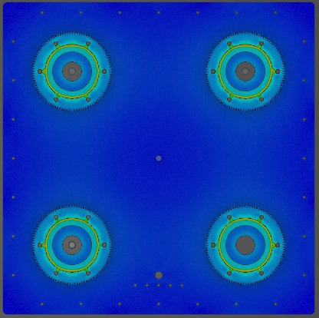The upper and side plates are laser cut from 2 mm ACP sheets. The bottom plate is laser cut from 3 mm AL6061 to support structural loads. The chassis frame is built using 2 mm × 20 mm × 20 mm AL6061 L-sections to guarantee strength and rigidity. The top plate has a 3 mm acrylic lid for easy access to the electronic components.

|  |  |
| --- | --- |
| Object Name | *Static Structural(A5)* |
| State | Solved |
| **Definition** | |
| Physics Type | Structural |
| Analysis Type | Static Structural |
| Solver Target | Discovery |
| **Options** | |
| Environment Temperature | 30. oC |
| Generate Input Only | No |

|  |  |  |  |
| --- | --- | --- | --- |
| Time[s] | Minimum[mm/mm] | Maximum[mm/mm] | Average[mm/mmm] |
| 0.2 | 4.0114e-010 | 2.826e-004 | 6.8293e-006 |
| 0.4 | 8.0229e-010 | 5.6521e-004 | 1.3659e-005 |
| 0.7 | 1.404e-009 | 9.8911e-004 | 2.3902e-005 |
| 1. | 2.0057e-009 | 1.413e-003 | 3.1416e-005 |

***Figure 10. Load Analysis***

ANSYS analysis verified strain and stress on all components, leading to design adjustments. Results confirmed deformations remained within limits, ensuring structural stability.

Each swerve module includes a 3D-printed ABS motor housing for the necessary strength. The gears are made of stainless steel to ensure they mesh accurately. A thrust bearing sits between the gear and motor housing to allow smooth movement and effective load distribution.

**4.2 Electronics and Hardware Integration**

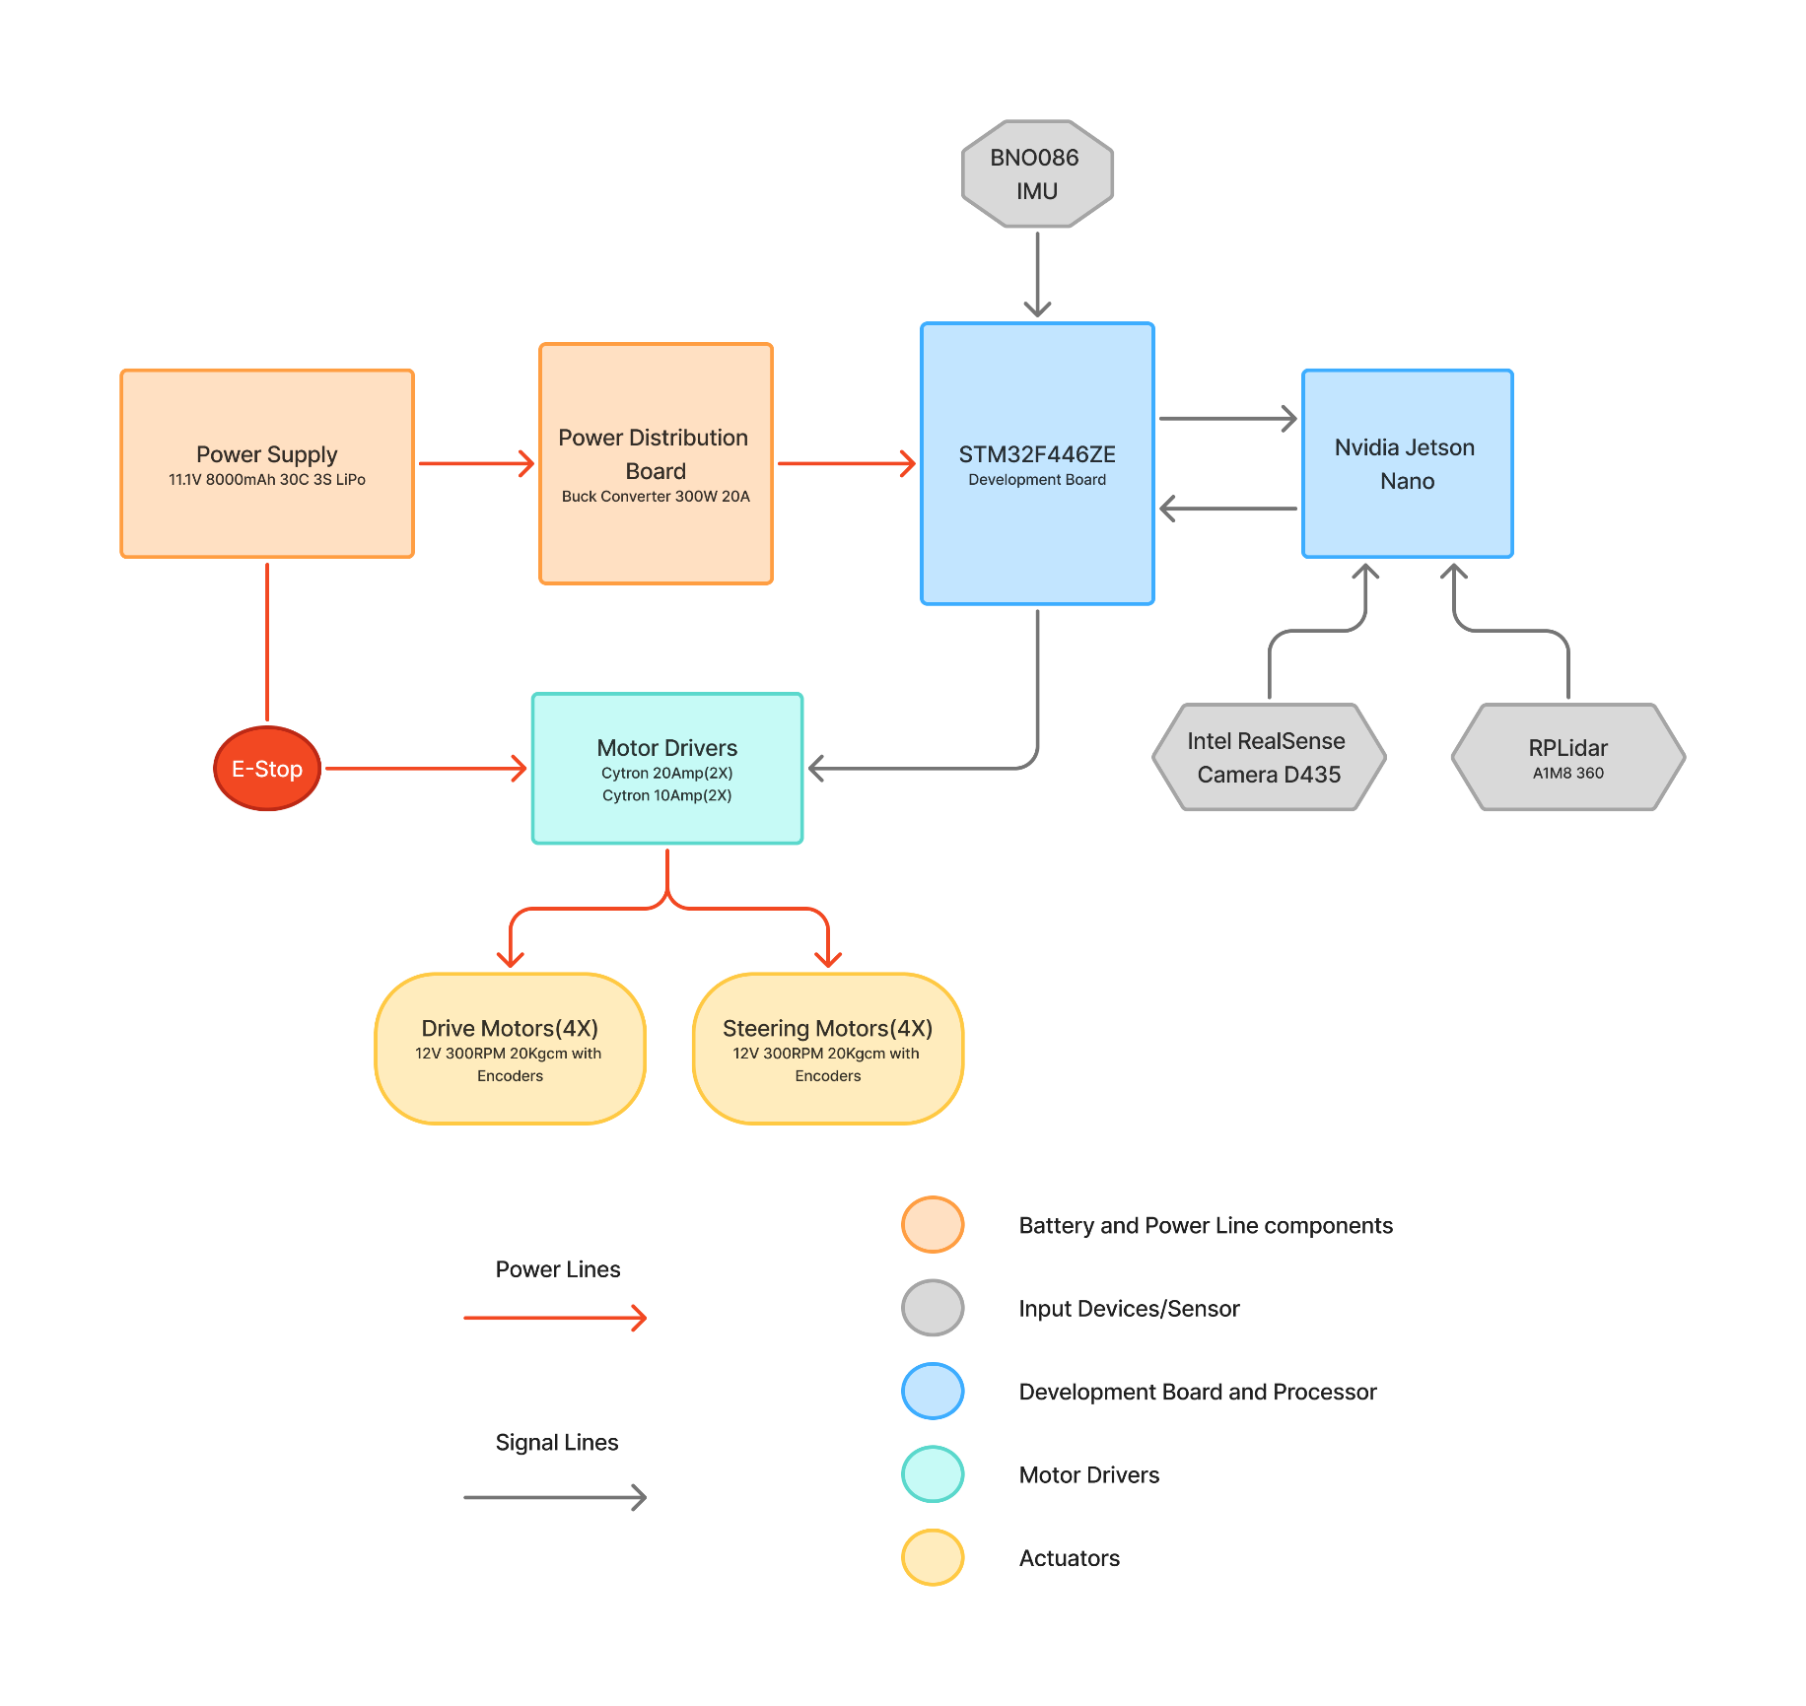

***Figure 11: Block Diagram***

The SR-01 system is powered by a 3S Li-Ion battery (11.1V, 10000mAh) with an Emergency Stop switch for immediate power cutoff. A Power Distribution Board manages voltage regulation, providing 12V for motors, 5V for computing/sensors, and 3.3V for peripherals.

The Jetson Nano serves as the main controller running ROS 2 Humble for perception, mapping, and navigation. It processes data from a RealSense D435i camera providing RGB and depth data for lane and obstacle detection and RPLiDAR A1M8 delivering 2D laser scanning for mapping. An IMU provides orientation data.

And Through sensor fusion, the Jetson performs SLAM, path planning, and obstacle avoidance, then transmits velocity and steering commands via UART to the STM32.

The STM32 microcontroller handles real-time control, implementing PID algorithms with encoder/IMU feedback to regulate drive and steering motors through PWM-based motor drivers.

Safety features include hardware E-Stop, STM32 watchdog timer (halts motors if Jetson commands timeout), and PDB overcurrent/short-circuit protection, ensuring reliable closed-loop operation for the SR-01.

**4.3 Software Integration (ROS 2)**

The SR-01 employs a ***"simulate first, test later"*** methodology using ROS 2 Humble with Gazebo and RViz2. It integrates RPLiDAR A1M8, RealSense D435, and BNO086 IMU through ROS 2 drivers. Localization uses an Extended Kalman Filter fusing IMU and encoder data for accurate state estimation.

Navigation leverages the Navigation2 stack featuring **NavFn** global planner for route calculation and Dynamic Window Approach **(DWA)** local planner for real-time collision avoidance. The costmap implements an innovative "lane-as-obstacle" approach, treating lane boundaries as virtual obstacles for enhanced planning precision.

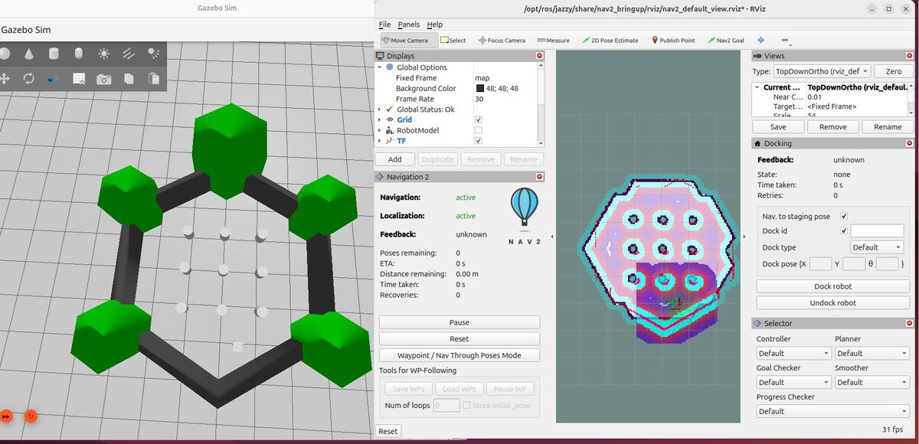

***Figure 12: Gazebo and Rviz Simulation in ROS2***

Mission execution utilizes waypoint files with built-in recovery behaviors. The RealSense camera processes RGB images through OpenCV for lane detection and QR/AR code scanning. IMU feedback enables terrain-adaptive control across varied surfaces.

The platform features **multi-modal drive**: **differential drive** for Stage1 navigation and **swerve drive** for precise later-stage maneuvering.

**Innovation:**

1. **Lane-as-Obstacle** methodology improves navigation by treating lane boundaries as virtual obstacles for accurate path planning.
2. **QR/AR-based mission upload** enables dynamic, flexible, and rapid task allocation.

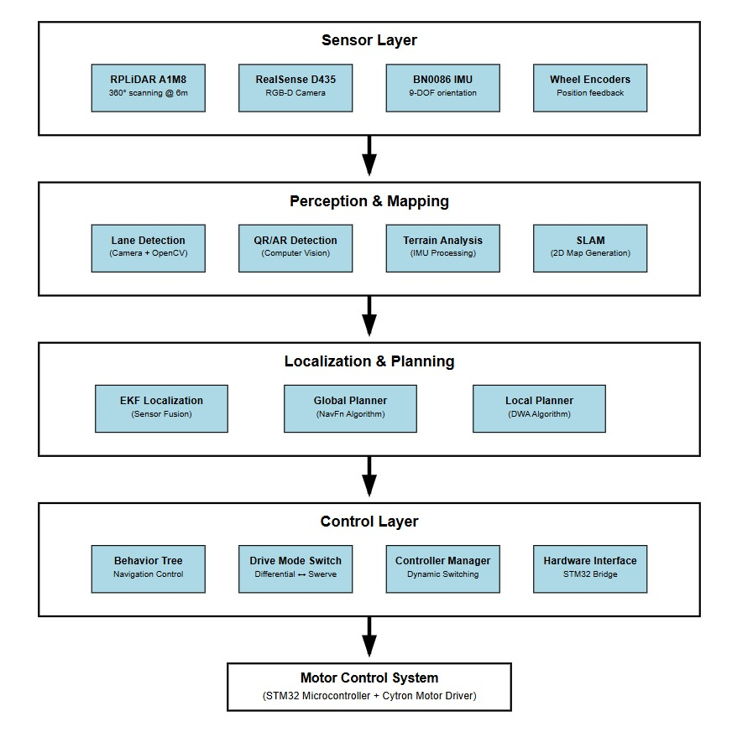

***Figure 13. Layered Architecture for Perception, Planning, and Control***

* 1. **Applications of the Proposed Robot in a Societal context**

The SR-01 robot has applications in several important sectors:

**1. Civil Applications**

* Autonomous delivery on campuses, in industries, and in smart cities.
* Agriculture: crop monitoring, soil analysis, precision spraying.
* Education and research include robotics, navigation, and AI testbed.

**2. Defence and Security**

* Army operations: reconnaissance and supply transport in dangerous areas.
* Security and surveillance: autonomous patrolling with live sensor feedback.

**3. Disaster Management**

* Transporting aid and resources in areas affected by disasters.
* Mapping hazardous zones using sensors.
* Helping rescue teams in dangerous environments.

**4. Healthcare**

* Moving medicines, equipment, and samples in hospitals.
* Reducing human exposure in contagious or high-risk areas.
  + 1. **Size of Robot – Proof of Concept (Small Version)**

**7.1 Dimensions**

|  |  |  |
| --- | --- | --- |
| **Sr. No.** | **Parameter** | **Value (mm)** |
| **1.** | Length | 477.41 |
| **2.** | Width | 443.44 |
| **3.** | Height | 433.63 |

***TABLE 4. POC DIMENSION***

**8. Size of Robot – Prototype (Full-Scale Version)**

**8.1 Final Dimensions**

|  |  |  |
| --- | --- | --- |
| **Sr. No.** | **Parameter** | **Value (mm)** |
| **1.** | Length | 650 |
| **2.** | Width | 500 |
| **3.** | Height | 500 |

***TABLE 5. PROTOTYPE DIMENSION***

* 1. **Timeline for Robot Development with Milestones**
  2. **Activity vs. Duration (Gantt Chart)**

|  |  |
| --- | --- |
| **Activity** | **Days** |
| Concept & Design | 8 |
| Fabrication & Assembly | 7 |
| Electronic Integration | 7 |
| Control System Programming | 10 |
| Testing & Calibration | 10 |
| Trial Runs | 10 |
| Optimization & Competition Ready | 7 |
| **Total** | **59** |

***TABLE 6. TIMELINE***

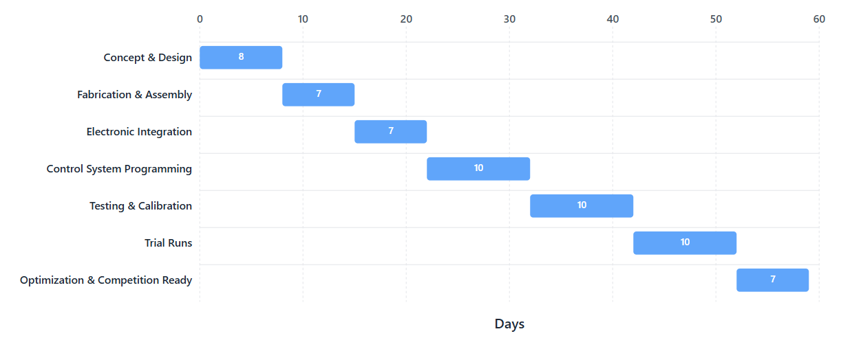

***Figure 14. Gantt Chart***

* 1. **Proposed Outline (Visual Representation)**

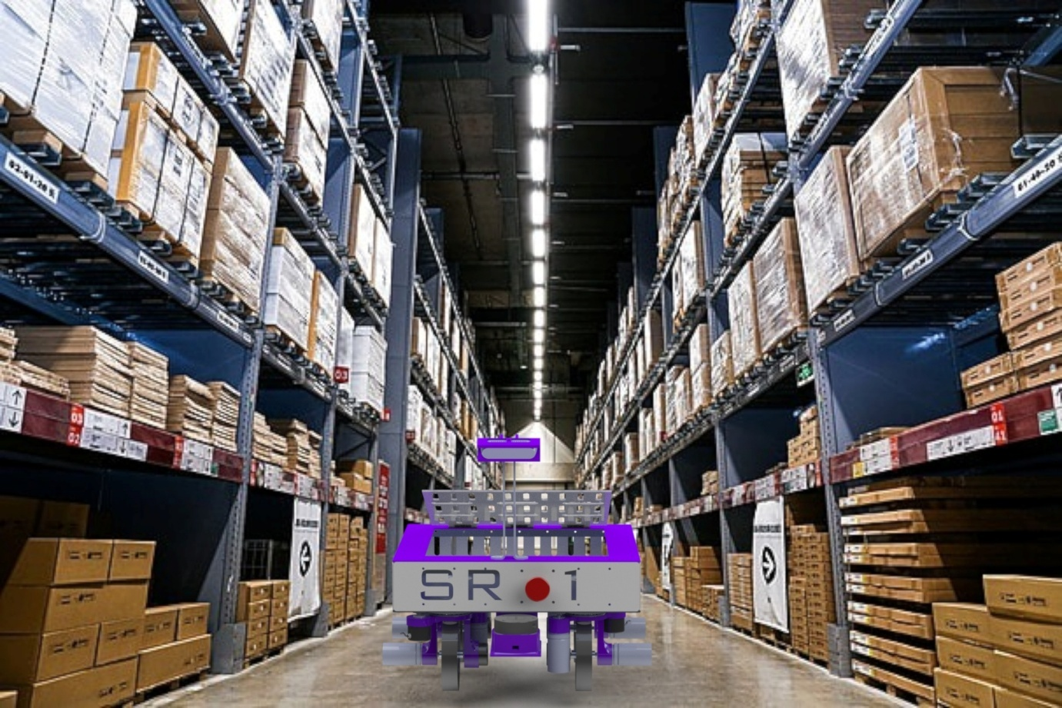

***Figure 15. Rendered Image of SR-01 in Real Environment***

* **Software and Tools Used:**

**1. Solidworks**

- To Design the SR 01 – The IGVC

**2. Ansys**

**-** For Strength and Stress Calculations on parts.

**3. Gazebo**

- For Simulation**.**

**4. Rviz**

- For Simulation.

**5. STM32CubeIDE**

- To Program the STM32 Board

**6. NAV2**

- For Navigation & Path Planning

**7. SLAM**

- For Mapping

**8. Logic**

- To Check the PWM Signals generated by STM

**9. Robo Studio**

- To configure Rotary LiDAR.

**10 *Yes I agree to file a patent of the proposed robot in ROBOFEST-GUJARAT 5.0 from the PIC Cell of GUJCOST***.

***Drive Link:***

[***https://drive.google.com/drive/folders/1u8TWyWWAxKJR6dseRA3k81Cty7CVw5OT***](https://drive.google.com/drive/folders/1u8TWyWWAxKJR6dseRA3k81Cty7CVw5OT)

***The complete design of the robot, along with detailed animations and all supporting documentation, has been uploaded to this Drive to provide a clearer and more comprehensive understanding.***